Talent, innovation and a sustainable urban-planning model position Barcelona, its metropolitan area and Catalonia at Expo Real

- Barcelona Catalonia is participating in this real estate fair in Munich to attract foreign investment

- Barcelona is ranked fourth among world cities in attracting talent, according to a study by EAE Business School

The Government of Catalonia, through INCASÒL; the Barcelona City Council and the Barcelona Metropolitan Area (AMB) are at Expo Real 2019 for the eleventh year in a row, renewing their commitment to the Barcelona Catalonia project to support inclusive, sustainable, cohesive development models. Expo Real is one of the top real estate fairs in the world, held this year from 7 to 9 October in Munich (Germany).

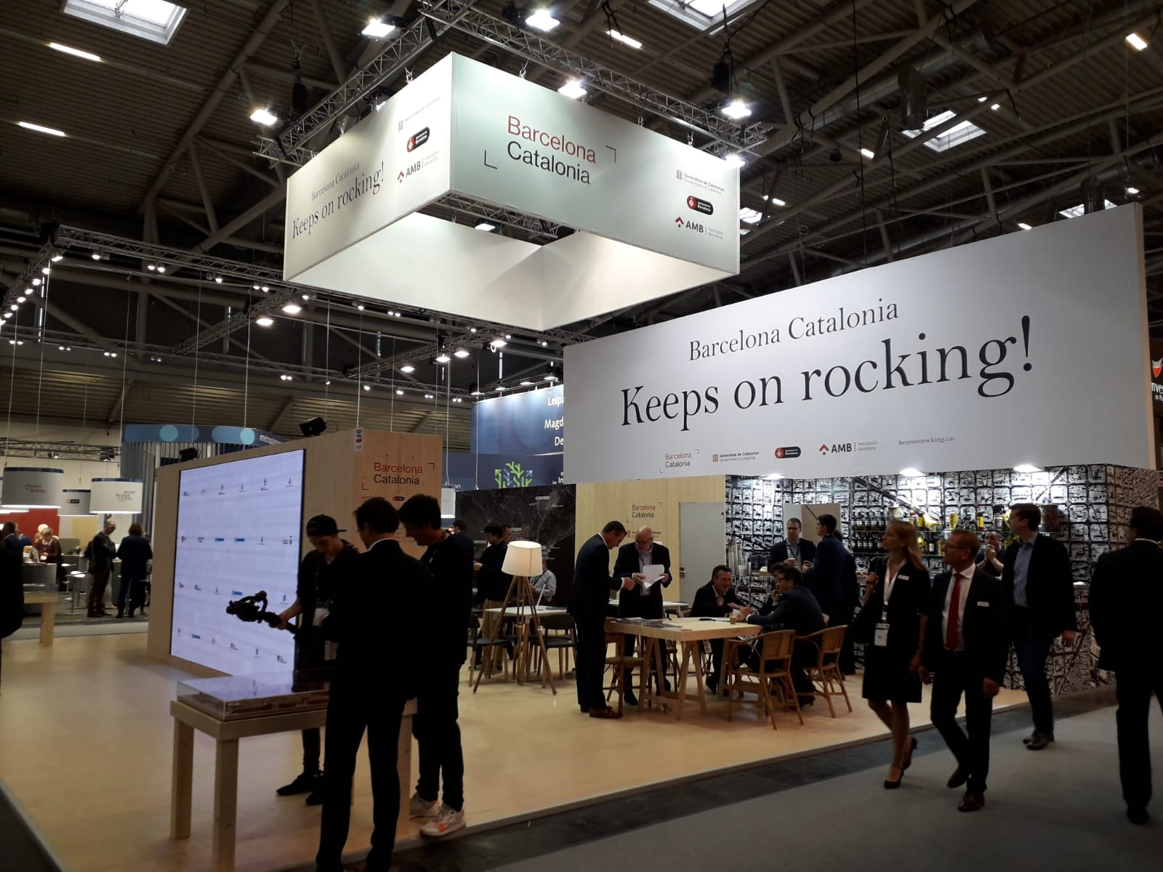

The projects Barcelona Catalonia is presenting under the slogan Keeps on rocking! reflect the international, open, cosmopolitan vocation of the city of Barcelona, its metropolitan area and Catalonia. These same factors, among others, have put the Catalan capital fourth on the ranking of world cities best at attracting talent, surpassed only by London, New York and Berlin. This is according to the study “La marca ciutat com a factor de creació de valor” (City brands as a way to generate value) compiled by EAE Business School, which analyses various aspects of each city, including its cultural capacity, level of intellectual wealth, creative capacity and ongoing innovation.

Furthermore, the city of Barcelona is also the third best start-up hub in Europe, based on data from 2018, just behind London and Berlin.

At this year's fair, Expo Real is inaugurating a new space, Nova³, devoted to innovation applied to the real estate sector. This way, the fair in Munich is joining the PropTech debate on how companies in the sector use technology to refine, improve or reinvent the services they offer. Catalonia is also facing challenges of this sort, which can be seen in the initiatives the Catalan government and city of Barcelona are working on with the main telecommunications providers to make Catalonia an open laboratory for 5G connections.

Barcelona Catalonia: Talent, Workspaces, Housing. Mix it to achieve it!

In this context, Barcelona, as a driving force for talent and incubator for start-ups and new workplace models, through the Barcelona Catalonia project, aims to participate in the debate and tackle the challenges arising from the mixed-use city model, in which people, innovation, talent and investment all co-exist. The second Barcelona Catalonia Conference: Talent, Workspaces, Housing. Mix it to achieve it! will attempt to address to this approach, as part of the official Expo Real programme. Roger Costa, FDI deputy director of Catalonia Trade & Investment (ACCIO), will moderate the panel discussion featuring Benjamin Nachoom, CEO of OneCoWork; Vanesa Carceller, CEO of JLL; and Maria Sisternas, CEO of MEDIAURBAN.

Beyond the conference hosted by Barcelona Catalonia, representatives of the Catalan delegation will also participate in other forums at Expo Real 2019, including the debate on the challenges facing seaside cities, the application of smart initiatives in neighbourhoods or districts, and the impact artificial intelligence can have on management of urban areas. These talks will be held on Monday and Tuesday as part of the Intelligent Urbanization Forum.

Public-private partnership for a joint offering for foreign investors

Barcelona Catalonia is consolidating is public-private partnership model, which includes proposals from various levels of government and those of private companies in the sector. As such, the Expo Real booth includes eight companies with an international outlook and municipal, metropolitan and supramunicipal governments working on urban-planning projects in Catalonia. This year, the participants are the city councils of Badalona, Gavà, l’Hospitalet de Llobregat, Sant Adrià de Besòs, Sant Boi de Llobregat and Viladecans; and companies like Europa Center, Fabregat Perulles Sales Abogados, Forcadell, Gina Barcelona Architects, Invest in the Center of Catalonia, JAP, L35 Architects and Meridiana.

7 October 2019

